Digital Electronics

Class 10
Lab 20

Lab Objectives:
- Encoder
- Mux

Encoder

An Encoder is a combinational circuit that performs the reverse operation of Decoder.

It has maximum of 2n input lines and ‘n’ output lines. It will produce a binary code equivalent to the input, which is active High.

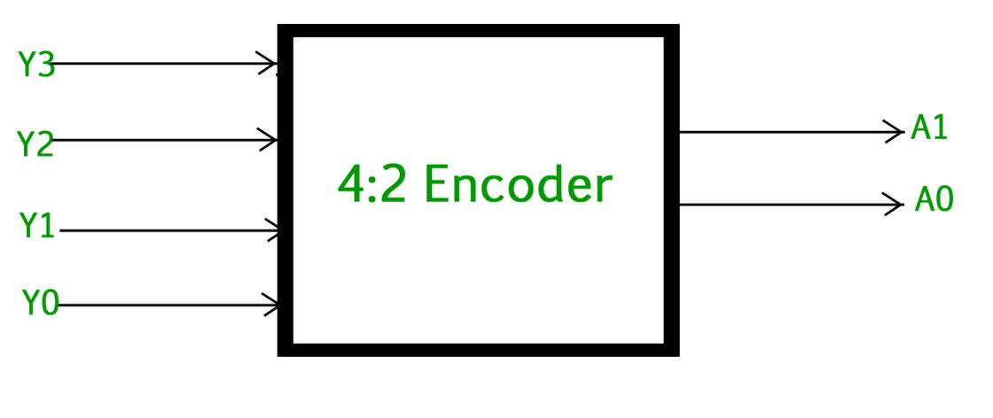

Inputs and Outputs for Encoder
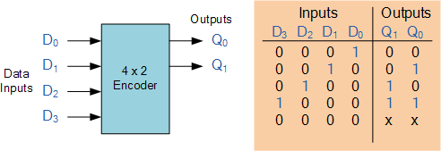

4 to 2 Encoder

Let 4 to 2 Encoder has four inputs Y3, Y2, Y1 & Y0 and two outputs A1 & A0. The block diagram of 4 to 2 Encoder is shown in the following figure.
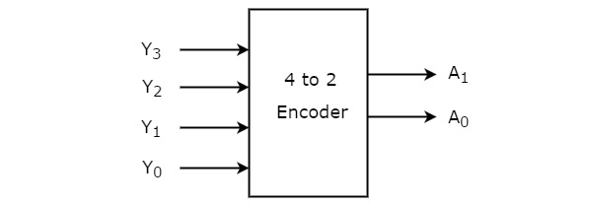

At any time, only one of these 4 inputs can be ‘1’ in order to get the respective binary code at the output. The Truth table of 4 to 2 encoder is shown below.

Inputs |  |  |  | Outputs
Y₃ | Y₂ | Y₁ | Y₀ | A₁ | A₀
0 | 0 | 0 | 1 | 0 | 0
0 | 0 | 1 | 0 | 0 | 1
0 | 1 | 0 | 0 | 1 | 0
1 | 0 | 0 | 0 | 1 | 1

From Truth table, we can write the Boolean functions for each output as
A1=Y3+Y2A1=Y3+Y2
A0=Y3+Y1A0=Y3+Y1

We can implement the above two Boolean functions by using two input OR gates. The circuit diagram of 4 to 2 encoder is shown in the following figure.

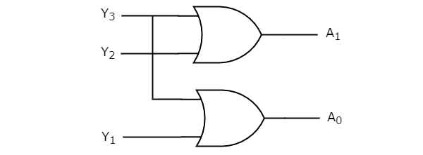

The above circuit diagram contains two OR gates. These OR gates encode the four inputs with two bits

Octal to Binary Encoder

Octal to binary Encoder has eight inputs, Y7 to Y0 and three outputs A2, A1 & A0. Octal to binary encoder is nothing but 8 to 3 encoder. The block diagram of octal to binary Encoder is shown in the following figure.
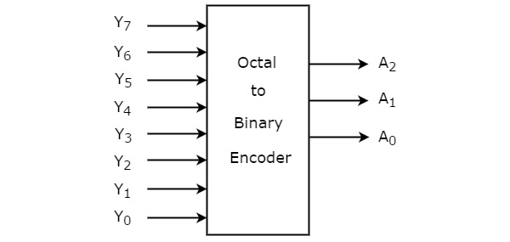

At any time, only one of these eight inputs can be ‘1’ in order to get the respective binary code. The Truth table of octal to binary encoder is shown below.

Multiplexer

Multiplexer is a combinational circuit that has maximum of 2^{n} data inputs, ‘n’ selection lines and single output line.

Multiplexer is also called as Mux.

4x1 Multiplexer

4x1 Multiplexer has four data inputs I3, I2, I1 & I0, two selection lines s1 & s0 and one output Y. The block diagram of 4x1 Multiplexer is shown in the following figure.
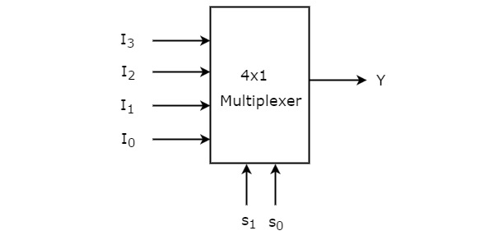

One of these 4 inputs will be connected to the output based on the combination of inputs present at these two selection lines. Truth table of 4x1 Multiplexer is shown below.

Selection Lines |  | Output
S₁ | S₀ | Y
0 | 0 | I₀
0 | 1 | I₁
1 | 0 | I₂
1 | 1 | I₃

